**Assignment - 4 Entity Relationships Diagram**

**and Database Development**

**School of Professional Studies**

[**Masters Research Project - 07 (Spring 2025)**](https://canvas.slu.edu/courses/70893)

**Professor:** [**Annamaria Szakonyi**](https://canvas.slu.edu/courses/70893/users/1379)

**Due Date: March 5th, 2025**



**Team 6**

**Group Members:**

**Amith Pitta**

**Lila Venkata Sairam Rayala**

**Mohanram Shrinivasan**

**Sai Ganesh Rao Patike Eranna**

* **Samyuktha Rani Pulagam**

**Designing an Entity Relationship Diagram (ERD) for the allyUserData database in the AllyBankingSystem (Created using Lucidchart)**

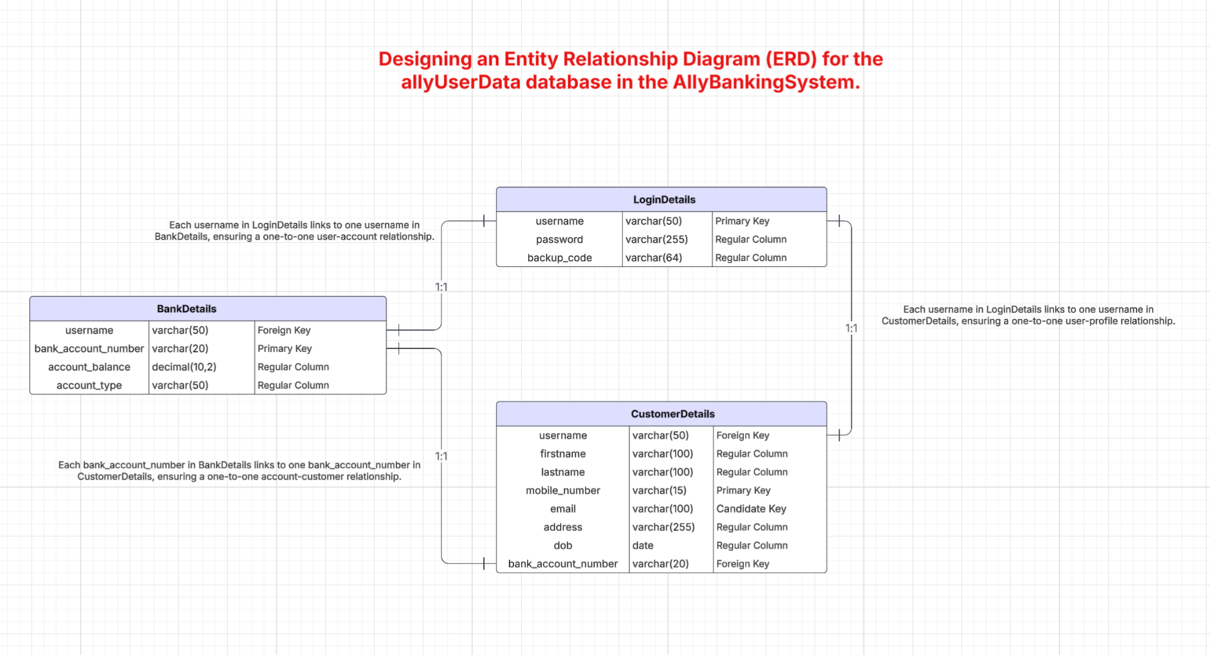

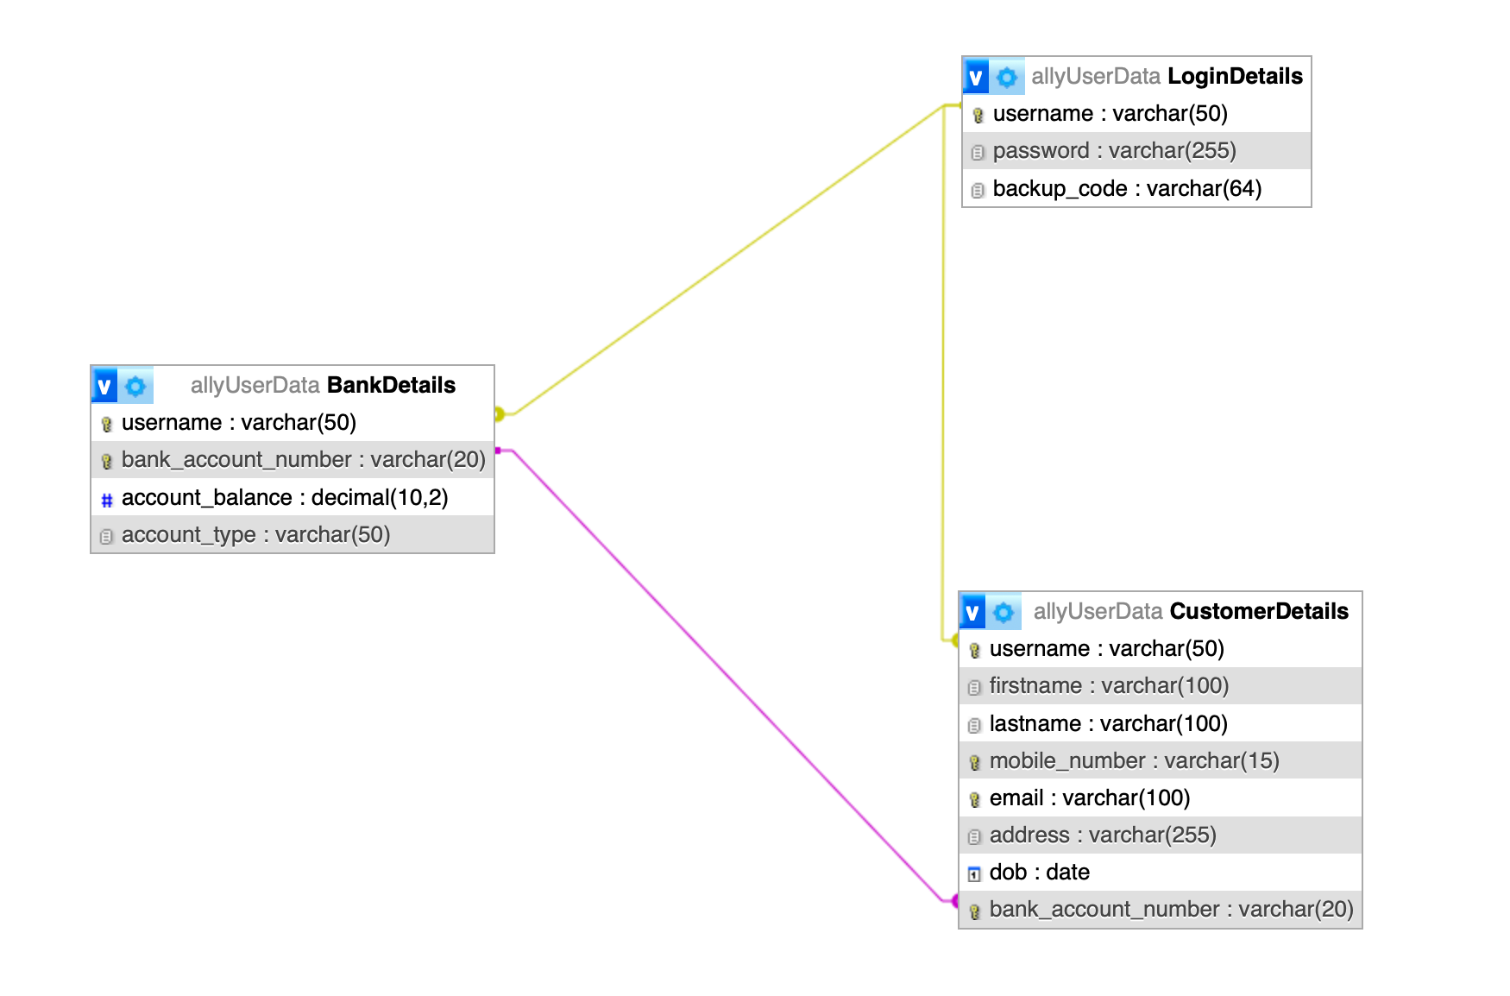

**Screenshots of the Data Used and Source of data (Executed in XAMPP (MySQL) and phpMyAdmin)**

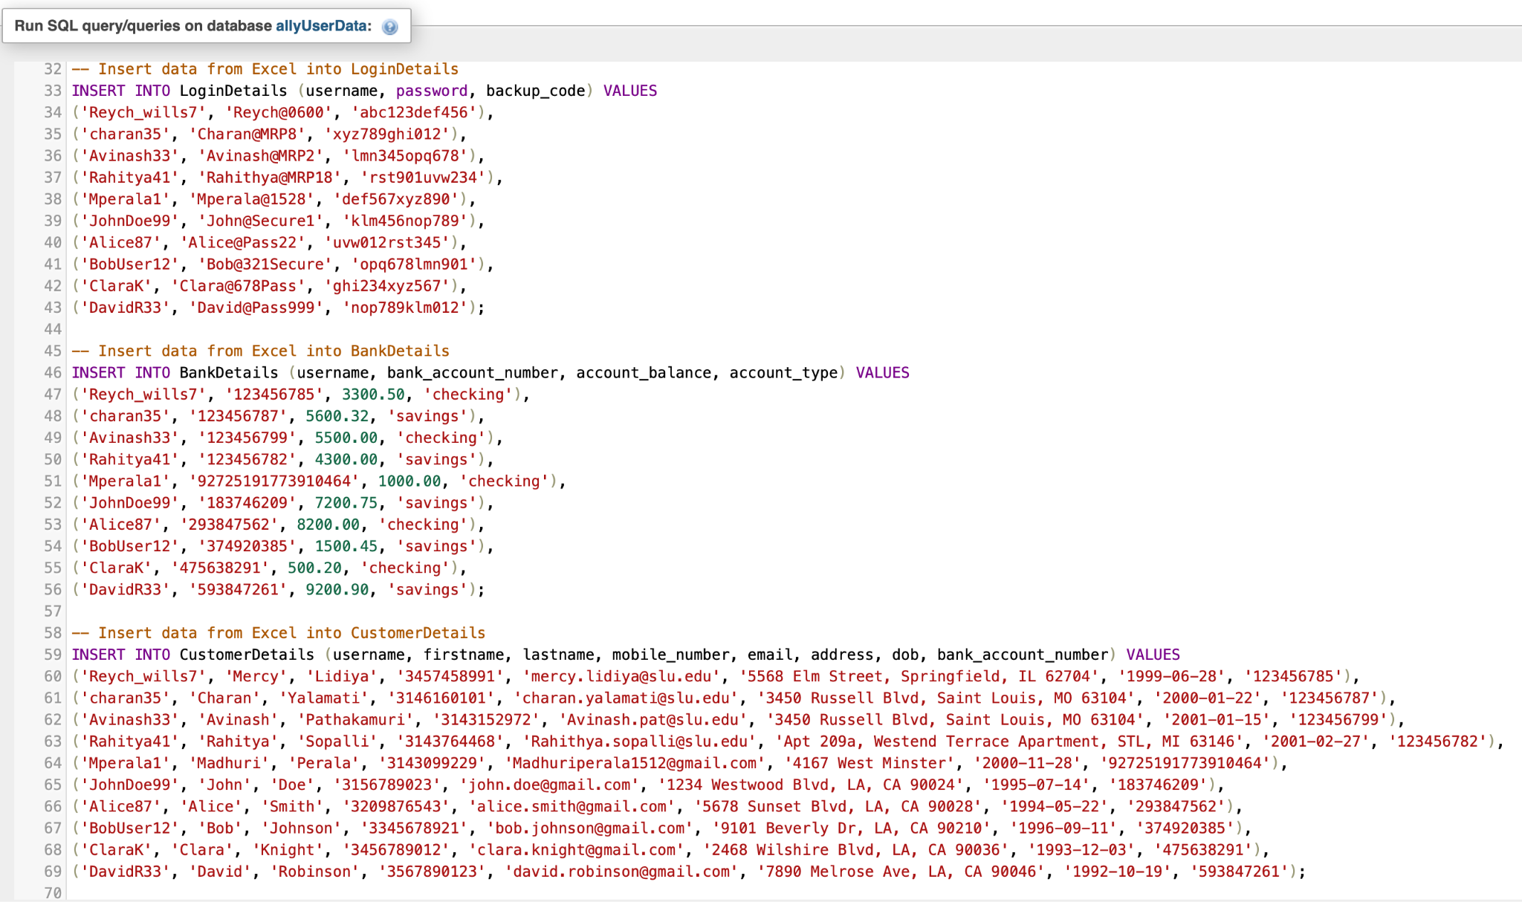

The data used in this project was collected from multiple sources:

1. Friends and Classmates:
   * Personal details such as first name, last name, email, mobile number, and address were gathered from friends and classmates who volunteered to contribute.
2. AI-Generated Fields:
   * Some fields, such as bank account numbers, account balances, and usernames, were generated using AI tools to maintain privacy and ensure uniqueness in the dataset (OpenAI, 2025).

**SQL Scripts for Table Creation, Inserts, and Queries (Executed in XAMPP (MySQL) and phpMyAdmin)**

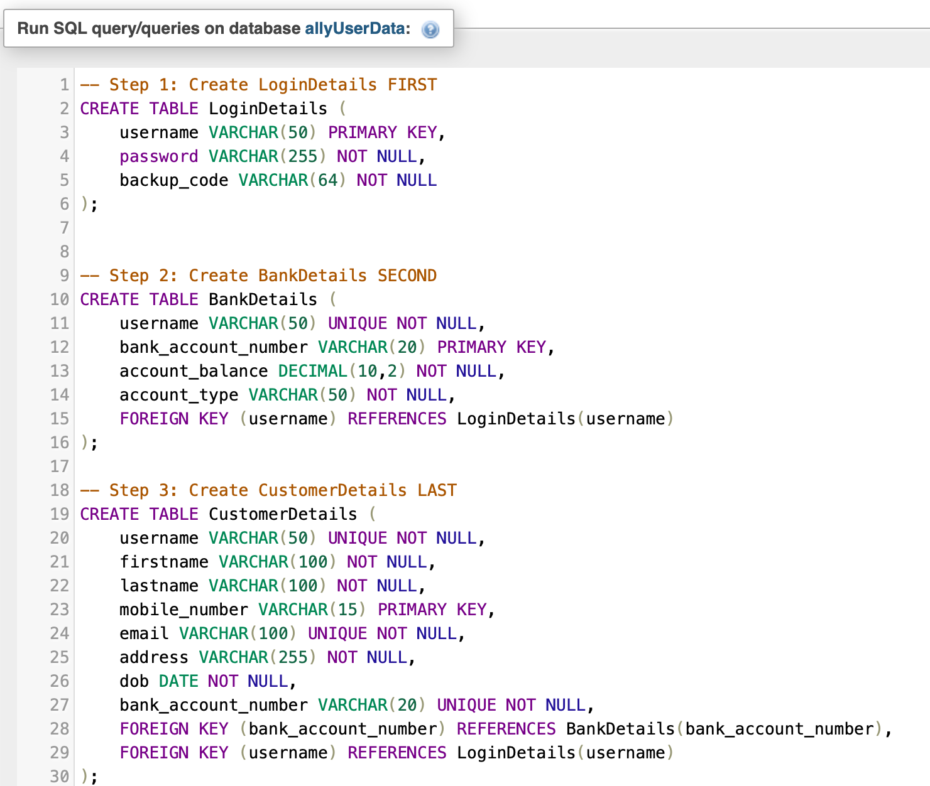



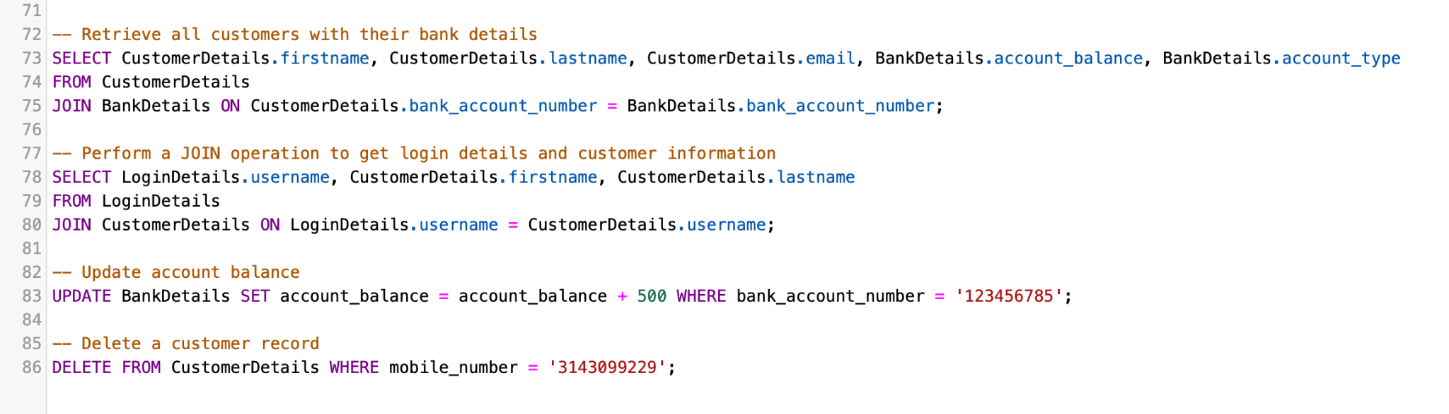

**Screenshots of Developed Working Database Prototype (Executed in XAMPP (MySQL) and phpMyAdmin)**

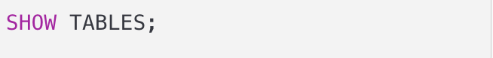

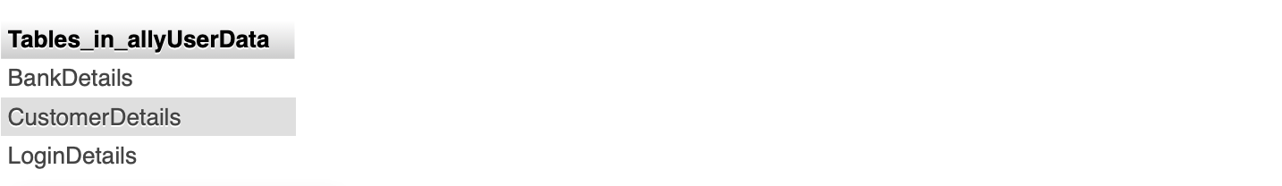

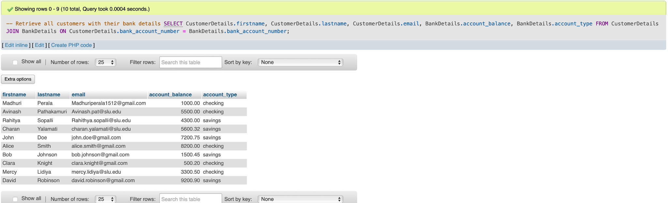

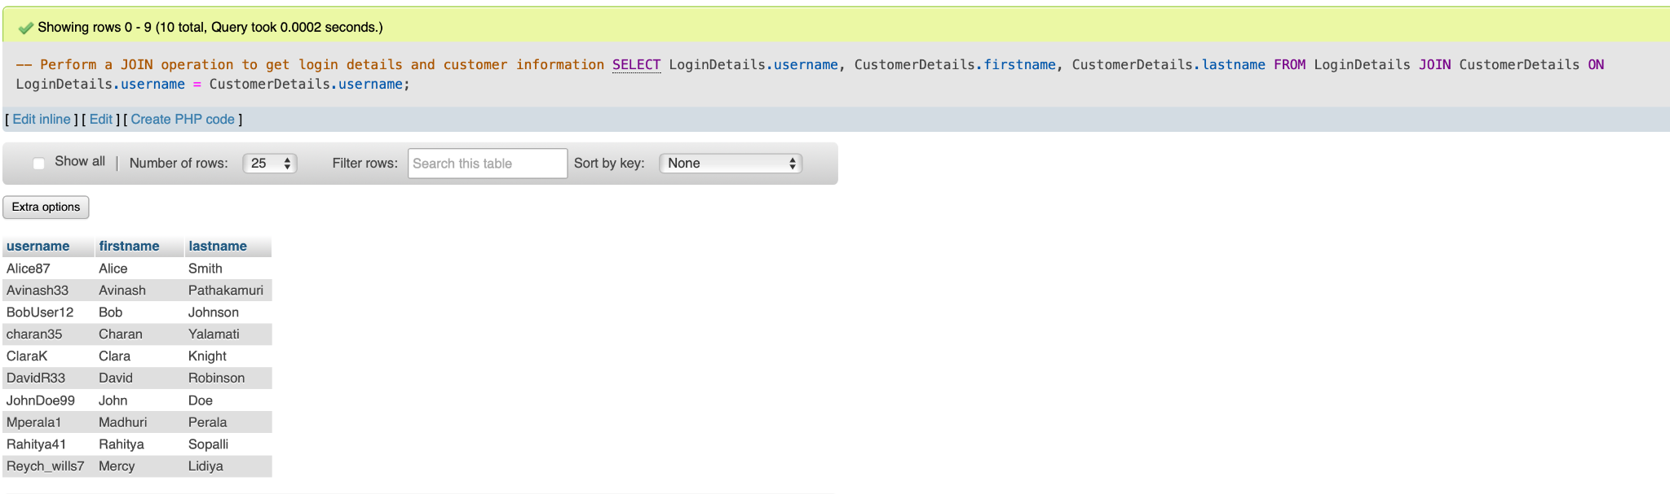



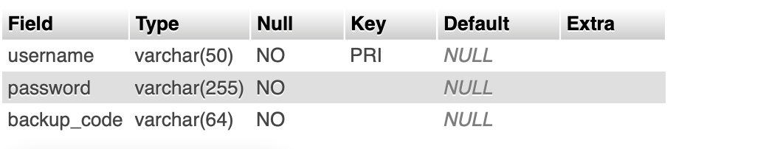

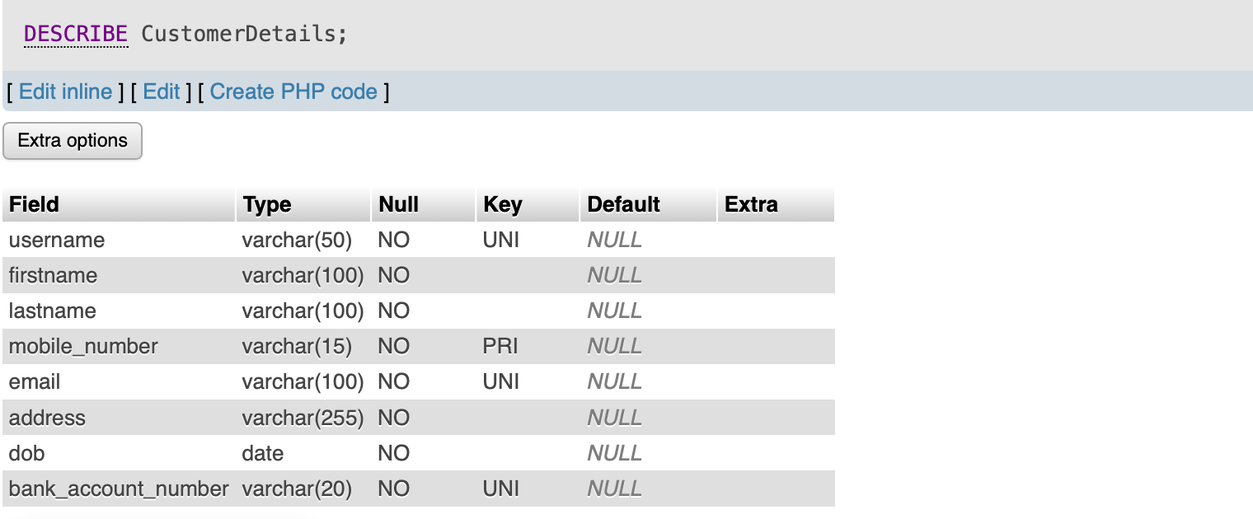

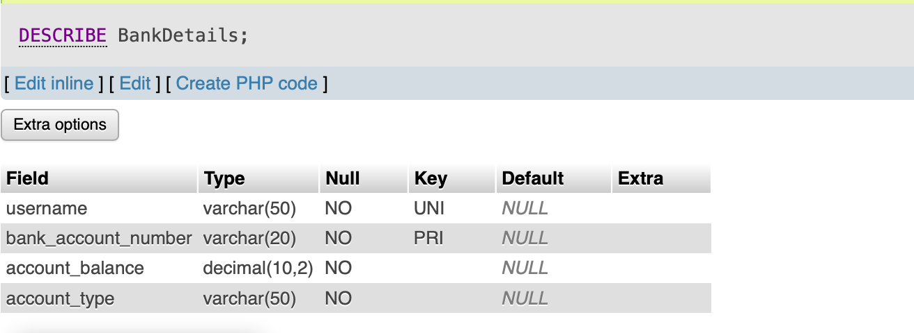

**References**

OpenAI. (2025). *ChatGPT (March 2025 version)* *[Large language model]. Retrieved from*

[**https://chat.openai.com**](https://chat.openai.com/)